IT 360 Cloud Integration | Week 3 | Lab 1 (Canvas 3.2)
Kubernetes on GKE with Helm and a NetworkPolicy
Click-by-click console steps with screenshots, the matching Cloud Shell commands, and the verification commands for the Silver Lake Credit Union loan calculator: an Autopilot cluster, a kubectl Deployment, a Helm release with rollback, and a NetworkPolicy proven by a blocked probe
Course: IT 360-01 Cloud Integration, Ensign College
Instructor: Jackson Isiko, Ph.D.
Canvas: 3.2 Team Lab 1, Kubernetes Cluster Setup on Google Kubernetes Engine, 40 points. Time: 90 minutes, 15 of them waiting for the cluster.
Companion documents: the README in gke-helm-networkpolicy/ (full guide, troubleshooting, the OpenTofu cluster definition) and the Week 3 video in videos/.
Version: 2026-10-29; verified against a live run on 2026-10-31. Console screenshots were taken from the live Google Cloud console on 2026-10-29, and every terminal figure is the real output of the instructor run on that day in project jackson-isiko.

How to use this document
Each step has two parts. The Console box tells you where to click, and the screenshot below it shows the same clicks as red numbered boxes. Under every screenshot a What you see paragraph explains the page and each mark. The Cloud Shell block gives the commands that do the same thing; they are what scripts/deploy-lab3-1.sh runs. The cluster is the only thing worth creating in the console; everything after it is kubectl and helm, which the Vocareum Cloud Shell has preinstalled.
Mac users: before pasting commands into Terminal. The Mac Terminal runs zsh, which does not treat # as a comment when you paste a line, so a line such as ... | grep NODE # note fails with grep: #: No such file or directory. Run setopt interactivecomments once in each new Terminal window and the comments are ignored. Replace every <...> placeholder, angle brackets included, before running a line: zsh and bash both read <word> as "take input from the file word" and fail with no such file or directory. Cloud Shell runs bash and needs only the second rule.
Customize these values to your environment. The instructor's cluster ended up in us-east1 because us-central1 had no Autopilot capacity that evening (two attempts failed with does not have enough resources available); the README uses us-central1, and either region works. Replace the project ID with yours, and keep the names below so the manifests in k8s/ apply unchanged.
Item | Value used in this guide | Yours
Project | jackson-isiko
Cluster | silverlake-public, Autopilot, region us-east1 (README: us-central1)
kubectl Deployment | loan-calc, 3 replicas of nginx:1.27, from k8s/nginx-deployment.yaml
Helm release | loan-calc from chart loan-calc-chart (Deployment loan-calc-loan-calc-chart, Service of the same name)
NetworkPolicy | loan-calc-frontend-only from k8s/network-policy.yaml: ingress only from pods labelled role=frontend

Watch out
An idle Autopilot cluster bills a control-plane fee of about 73 dollars a month. Delete it in Part F the same day, and end the Vocareum lab. If a cluster creation fails with does not have enough resources, delete the errored cluster and create it again in another region; the manifests do not care which.

Part A. The cluster (15 min, mostly waiting)

Step 1. Create an Autopilot cluster
Console: where to click
Kubernetes Engine → Clusters and click Create (1). The instructor's list already shows silverlake-public (2); yours is empty.
In the chooser, click Configure (2) under Autopilot: Google manages your cluster (Recommended). If the Navigate at a glance tour opens over the form, close it with the X at the top right of the blue card.
Cluster basics: Name silverlake-public (the field the tour card covers in the figure), Region (2) us-central1 (or any region with capacity). Leave the other steps at their defaults and click Create (3). The cluster takes 6 to 15 minutes; it shows a spinner in the list until it is RUNNING.

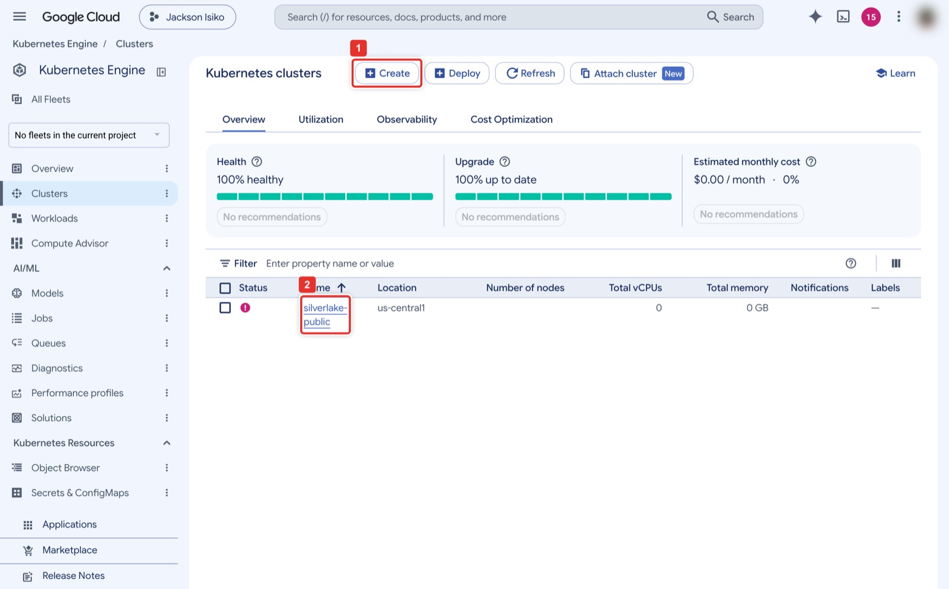
Figure 1. Kubernetes Engine → Clusters → Create.
What you see: The Clusters overview. Create (1) at the top opens the mode chooser. The list shows the instructor's silverlake-public (2) in us-central1 with a red error icon and 0 nodes: this is the attempt that failed with does not have enough resources available. A cluster being created shows a spinner instead, and a running one a green check. Your list starts empty.
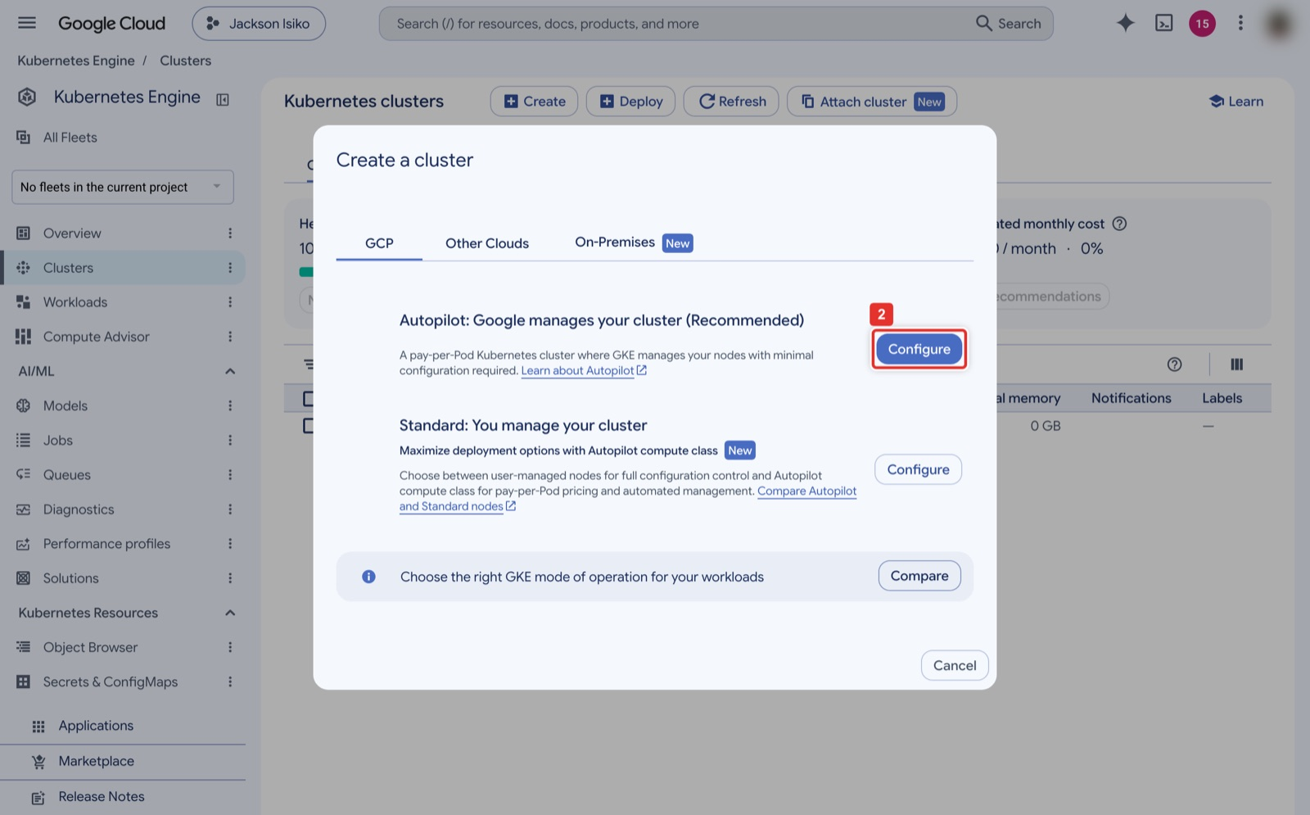
Figure 2. Autopilot (recommended) or Standard: click Configure under Autopilot.
What you see: The mode chooser. Autopilot on the left is the recommended mode: Google manages the nodes and, importantly for Part D, enforces NetworkPolicy with Dataplane V2 by default. Configure (2) under it opens the Autopilot form. Standard, on the right, needs Dataplane V2 chosen at creation time or the policy proof silently fails; do not pick it for this lab.
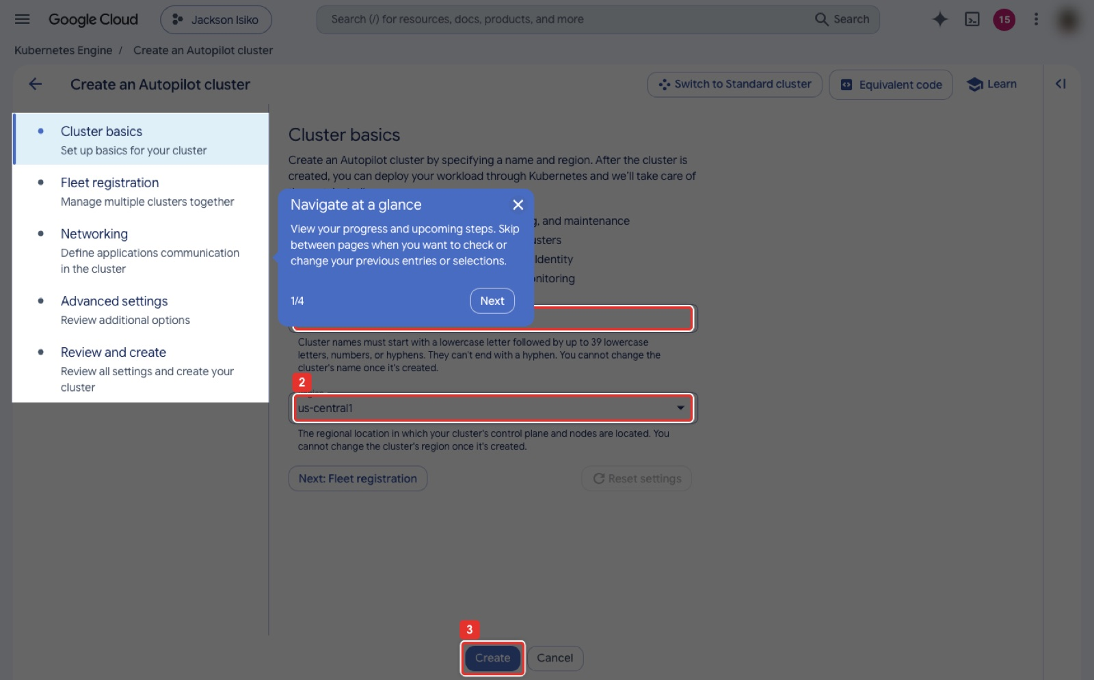
Figure 3. Cluster basics: the Navigate at a glance tour over the Name field, the region, Create.
What you see: The Cluster basics step of the Autopilot form. In this figure the blue Navigate at a glance tour card still covers the Name field, which is where silverlake-public goes; close the tour with its X to reach the field. Region (2) is the region the cluster lives in; name and region are both permanent. Fleet registration, Networking, Advanced settings and Review stay at their defaults. Create (3) at the bottom starts provisioning; the Equivalent code button at the top shows the same gcloud container clusters create-auto command that the Cloud Shell block uses.
Cloud Shell (same result)
gcloud container clusters create-auto silverlake-public --region us-central1 # instructor: --region us-east1
gcloud container clusters get-credentials silverlake-public --region us-central1
gcloud container clusters list
kubectl get nodes # Autopilot may show no nodes until a workload is scheduled

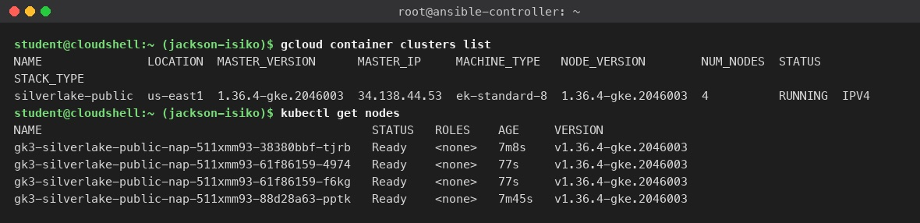
Figure 4. The cluster RUNNING, and kubectl listing the nodes Autopilot added for the workloads.
What you see: gcloud container clusters list is Validation 1: silverlake-public in us-east1 with STATUS RUNNING, master version 1.36. kubectl get nodes shows the gk3-... nodes Autopilot added (the count varies from run to run): Autopilot created them for the pods of Parts B and C and will remove them when the pods go. Right after creation the node list may be empty; that is normal.
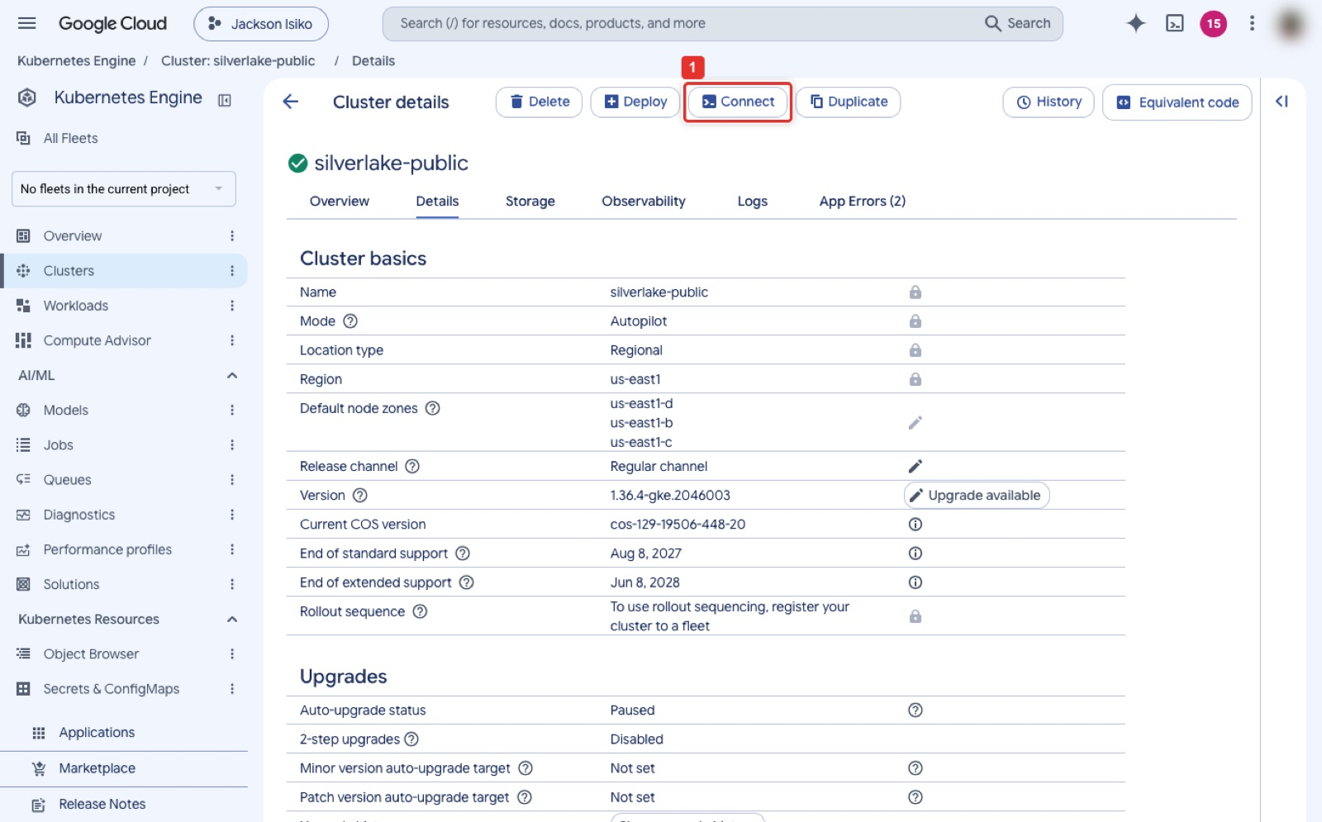
Figure 5. The running cluster's detail page.
What you see: The cluster detail page after creation: status is a green check, the mode is Autopilot, the region and the control-plane version are listed, and the Connect button (1) at the top prints the get-credentials command for your terminal. The Workloads and Services tabs on the left are where Parts B and C become visible.
Expected result
The list shows silverlake-public RUNNING. That is Validation 1.

Part B. Deploy with kubectl (10 min)

Step 2. Apply the Deployment and watch Kubernetes replace a pod
Cloud Shell
kubectl apply -f k8s/nginx-deployment.yaml
kubectl rollout status deployment/loan-calc
kubectl get deployments
kubectl get pods
kubectl delete pod <one pod name> # checkpoint: a replacement appears within seconds
kubectl get pods

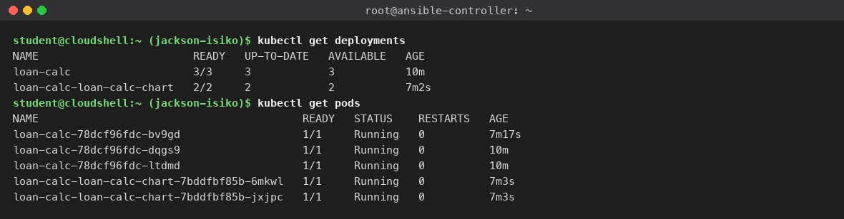
Figure 6. Deployments and pods: loan-calc 3/3 plus the Helm release's 2/2.
What you see: kubectl get deployments lists loan-calc with READY 3/3 (the kubectl Deployment of this part) and loan-calc-loan-calc-chart 2/2 (the Helm release of Part C, created later). kubectl get pods shows the five pods Running; the first loan-calc pod is younger than the other two because the instructor deleted the original and the ReplicaSet replaced it in 9 seconds on 2026-10-29 (7 seconds on 2026-10-24); the picture was taken minutes later, after Part C. Screenshot 1 is the three Running pods.
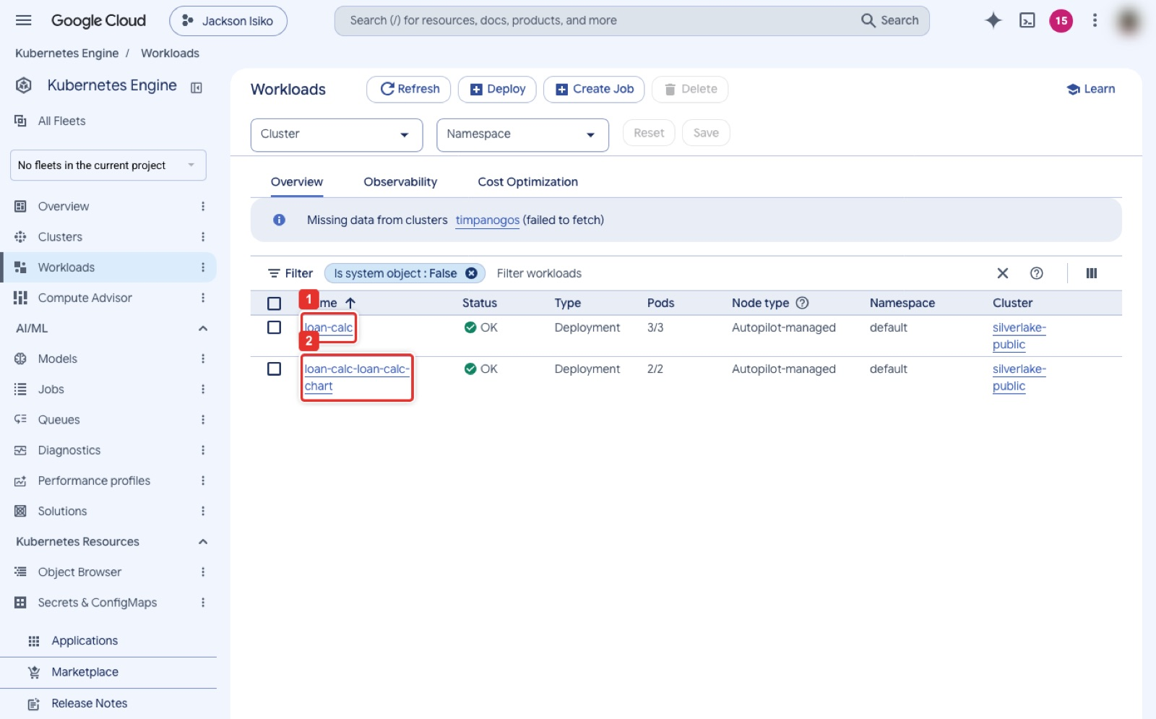
Figure 7. Kubernetes Engine → Workloads: the two Deployments.
What you see: The Workloads page lists both Deployments, loan-calc (1) and loan-calc-loan-calc-chart (2), with status OK, type Deployment, the number of pods and the cluster. Clicking a name opens its detail with the pods and the YAML. If a Deployment shows Does not have minimum availability, Autopilot is still provisioning a node for it.
Expected result
Three pods Running (Validation 2). Checkpoint: who restored the deleted pod? The ReplicaSet behind the Deployment, reconciling to replicas: 3.

Part C. Manage with Helm (20 min)

Step 3. Install, upgrade, roll back
Cloud Shell
helm version
helm create loan-calc-chart
sed -i.bak 's/^replicaCount: .*/replicaCount: 2/' loan-calc-chart/values.yaml # -i.bak: works on Cloud Shell and macOS
sed -i.bak 's/^ tag: .*/ tag: "1.27"/' loan-calc-chart/values.yaml
helm install loan-calc ./loan-calc-chart
helm list
sed -i.bak 's/^replicaCount: .*/replicaCount: 3/' loan-calc-chart/values.yaml
helm upgrade loan-calc ./loan-calc-chart
helm rollback loan-calc 1
helm history loan-calc
helm history loan-calc | grep deployed

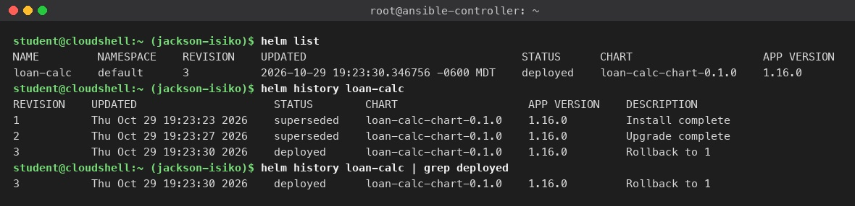
Figure 8. helm list and helm history: revision 3 deployed, Rollback to 1.
What you see: helm list shows one release, loan-calc, at REVISION 3, STATUS deployed. helm history is Validation 3: revision 1 Install complete (superseded), revision 2 Upgrade complete (superseded), revision 3 Rollback to 1 (deployed). The grep answers the checkpoint: revision 3 is live, and it is the same configuration as revision 1, two replicas. That one-command rollback is what the infrastructure manager asked for.
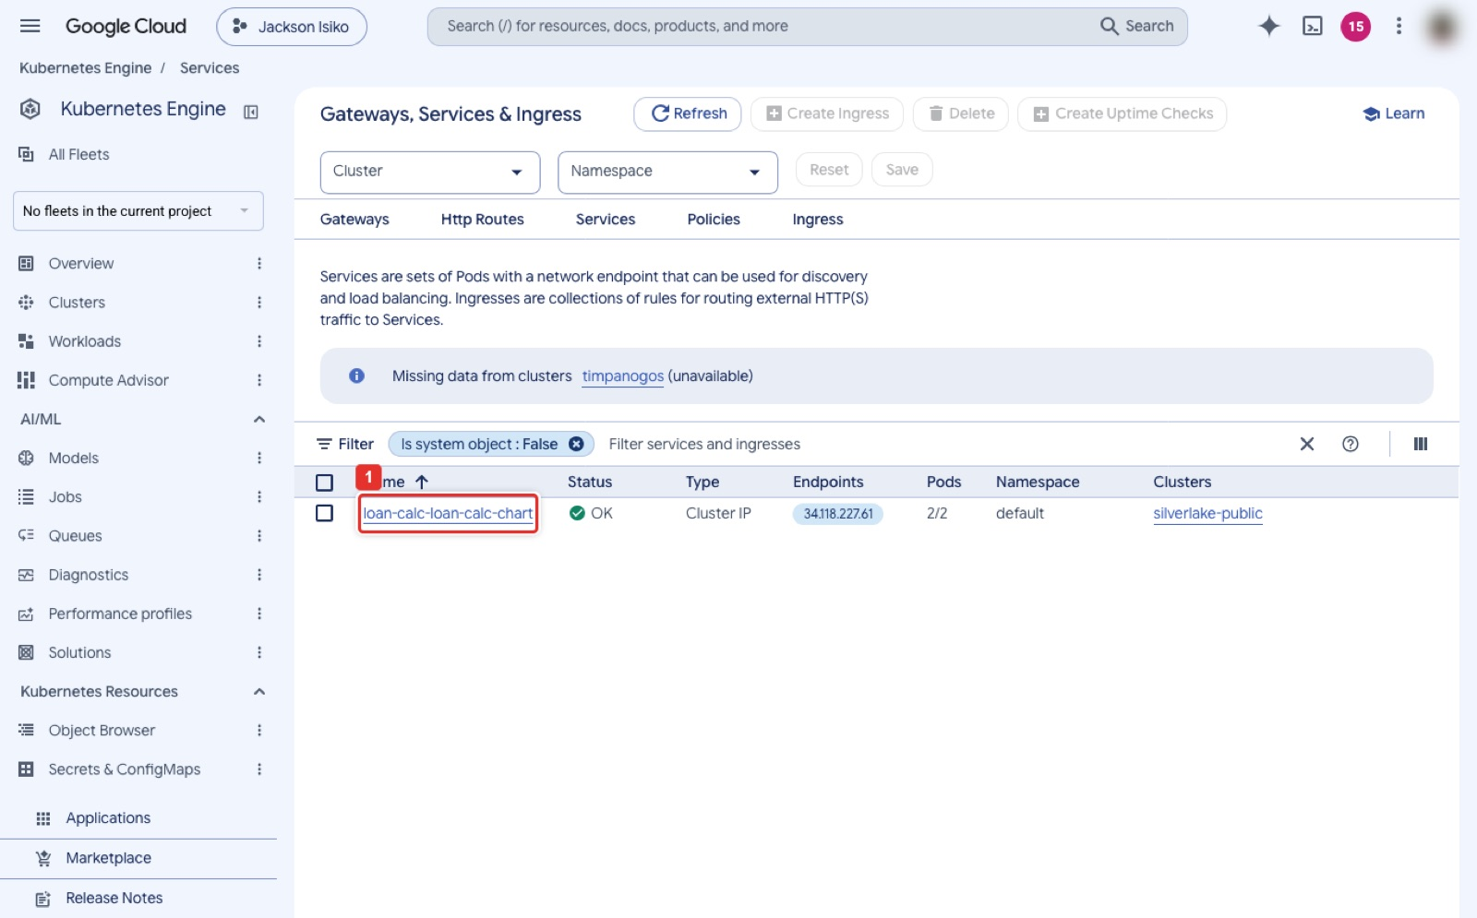
Figure 9. Kubernetes Engine → Gateways, Services & Ingress: the Helm release's ClusterIP Service.
What you see: The Services page. loan-calc-loan-calc-chart (1) is a ClusterIP Service on port 80 with no external endpoint, which is why the probes in Part D run from inside the cluster. If you did the optional kubectl expose ... --type=LoadBalancer, a second Service with an external IP appears here.

Part D. The NetworkPolicy, with proof (20 min)

Step 4. Apply the policy and run both probes
Cloud Shell
kubectl apply -f k8s/network-policy.yaml
kubectl get networkpolicy
SVC=$(kubectl get svc -l app.kubernetes.io/instance=loan-calc -o jsonpath='{.items[0].metadata.name}')
# negative test: no label, must time out
kubectl run probe --rm -it --image=busybox:1.36 --restart=Never -- wget -qO- --timeout=5 http://$SVC
# positive test: labelled, must print the nginx HTML
kubectl run probe-ok --rm -it --image=busybox:1.36 --restart=Never --labels=role=frontend -- wget -qO- --timeout=5 http://$SVC

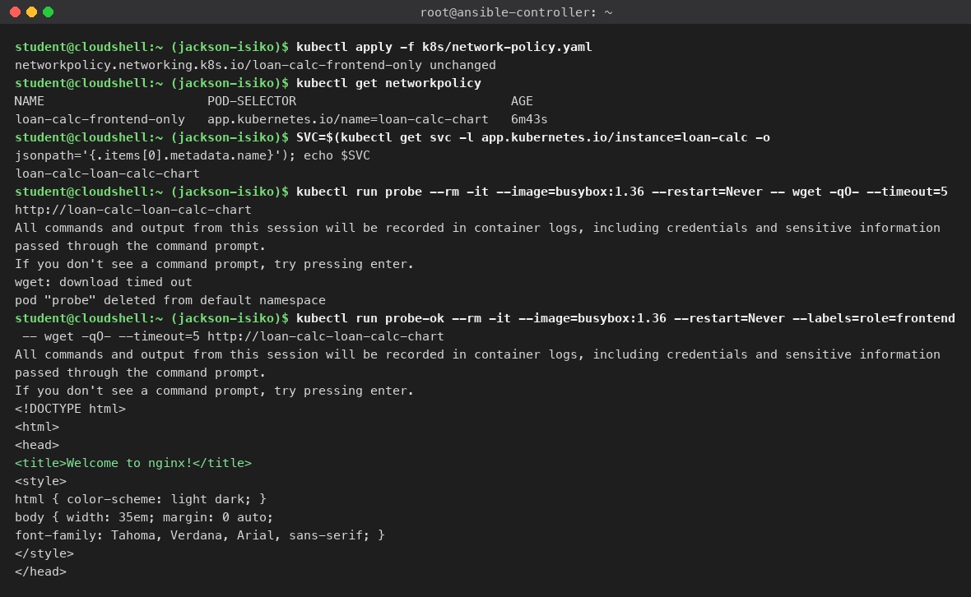
Figure 10. The policy applied, the unlabelled probe timing out, the role=frontend probe getting the NGINX page.
What you see: Validation 4 in one terminal. kubectl get networkpolicy lists loan-calc-frontend-only selecting the chart's pods. The first kubectl run starts a busybox pod with no label and its wget prints download timed out: the policy dropped the connection. The second probe carries --labels=role=frontend and prints the NGINX welcome HTML. The All commands and output from this session will be recorded in container logs... and If you don't see a command prompt, try pressing enter. lines (with the Autopilot resources warning before them) are printed by GKE for every interactive kubectl run; they are not errors and the probe has not hung. After the timed-out line the blocked probe also prints pod "probe" deleted from default namespace and pod default/probe terminated (Error): the non-zero wget exit is what --restart=Never reports. That timed-out request is the evidence the auditor reads.
Expected result
Probe one times out, probe two prints the HTML. Screenshot 3 is both results in one terminal.

Part E. Verify the deployment (10 min)
Check | Command in Cloud Shell | Expected
Cluster is up and reachable | gcloud container clusters list then kubectl get nodes | RUNNING; nodes Ready
Everything in the namespace | kubectl get all | 5 pods, 2 Services (kubernetes and loan-calc-loan-calc-chart, both ClusterIP), 2 Deployments, 2 ReplicaSets
Which Helm revision is live | helm history loan-calc | grep deployed | revision 3, Rollback to 1
Release health | helm status loan-calc | STATUS: deployed, REVISION: 3
Policy is what you think it is | kubectl describe networkpolicy loan-calc-frontend-only | From PodSelector: role=frontend, Policy Types: Ingress
Policy is enforced | the two probes of Step 4 | timed out, then HTML
What happened recently | kubectl get events --sort-by=.lastTimestamp | tail -8 | probe pods Scheduled, Pulled, Started
Rollout history of the release | kubectl rollout history deployment/loan-calc-loan-calc-chart | one revision: the upgrade changed only replicaCount, which is not part of the pod template

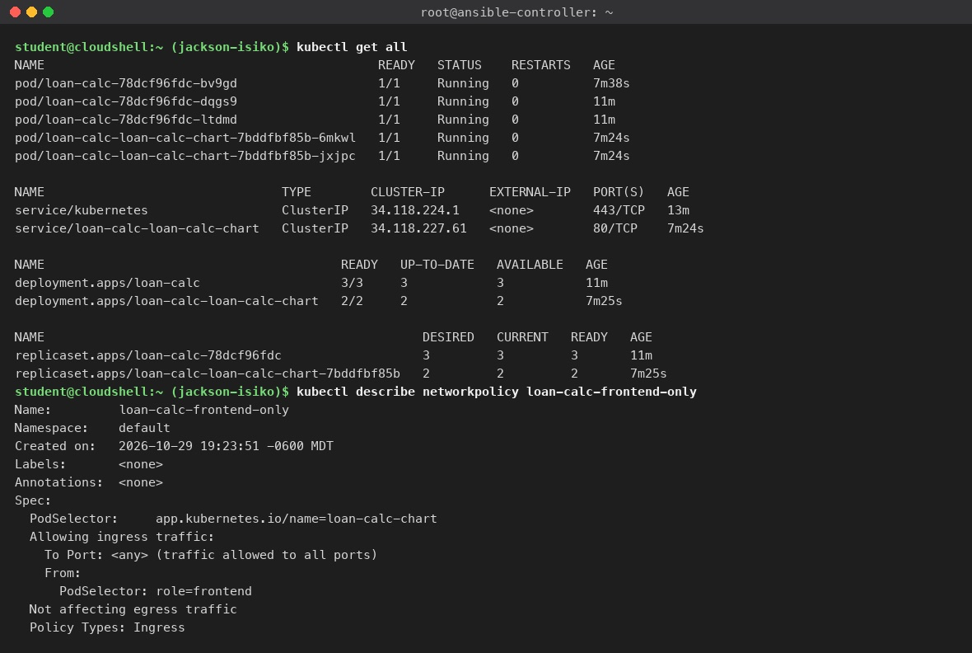
Figure 11. kubectl get all and the NetworkPolicy described.
What you see: kubectl get all lists everything the lab created in the default namespace: five pods, the kubernetes and loan-calc-loan-calc-chart Services (both ClusterIP), two Deployments and their ReplicaSets. kubectl describe networkpolicy restates the rule in words: the chart's pods accept ingress on any port only From PodSelector role=frontend, and egress is not affected. If Allowing ingress traffic showed From: <any>, the policy would be the permissive Canvas version.
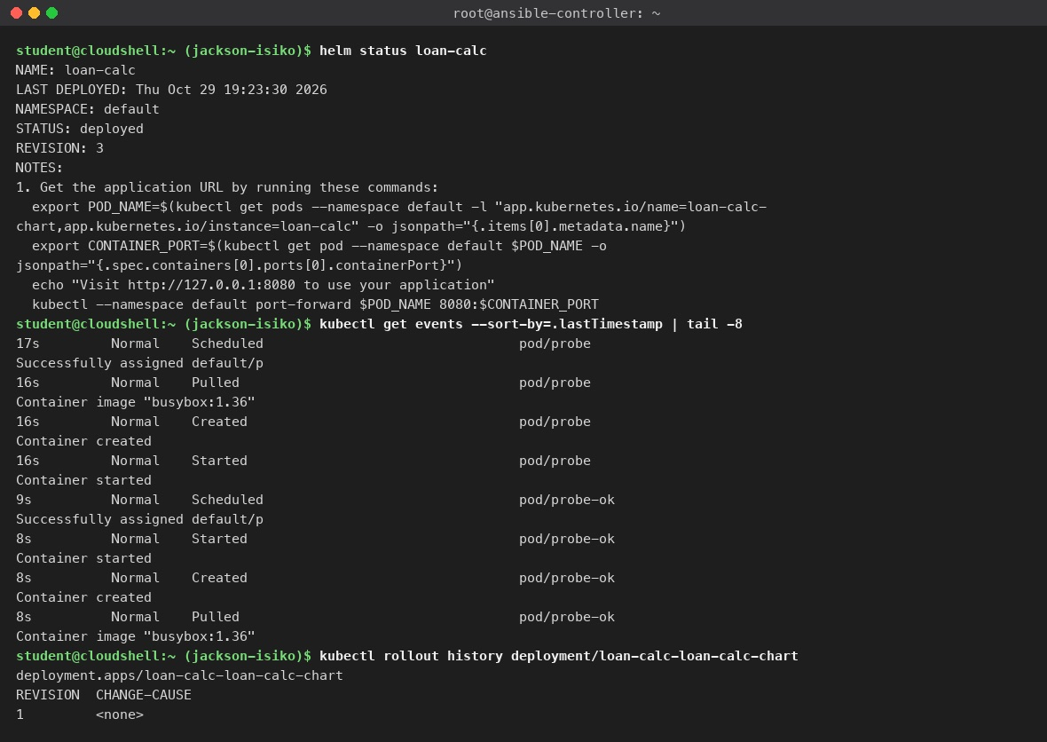
Figure 12. helm status, the latest events, and the Deployment's rollout history.
What you see: helm status loan-calc repeats the release state and prints the chart's NOTES, including a port-forward command you can use to open the calculator locally. The last eight events are the two probe pods being scheduled, pulled and started, which is how you can tell the negative probe ran rather than failed to start. kubectl rollout history shows a single revision because the upgrade only changed replicaCount (2 to 3), which is not part of the pod template: a Deployment records a rollout revision only when .spec.template changes, so neither the upgrade nor the rollback created a new ReplicaSet or revision.
Note
From a laptop with gcloud, kubectl and helm: bash scripts/deploy-lab3-1.sh <PROJECT_ID> runs Parts A to D with every validation printed; REGION=us-east1 picks another region and CLUSTER=<name> renames the cluster. On a rerun it uninstalls the existing loan-calc release first, so helm history again reads revisions 1, 2 and 3.

Part F. Clean up (5 min)
Cloud Shell
helm uninstall loan-calc
kubectl delete -f k8s/network-policy.yaml -f k8s/nginx-deployment.yaml
gcloud container clusters delete silverlake-public --region us-central1 --quiet # instructor: --region us-east1
# or: bash scripts/rollback-lab3-1.sh <PROJECT_ID> -y (add --keep-cluster to reuse it in Week 4)

Expected result
gcloud container clusters list prints nothing from this lab. End the Vocareum lab as well.

Part G. What to submit (Canvas 3.2)
- Screenshot 1: three pods Running. Screenshot 2: helm history with revisions 1, 2 and 3. Screenshot 3: both probe results in one terminal.
- The NetworkPolicy YAML, the helm list and helm history output.
- The Canvas summary with the Team Collaboration and Documentation section.

Appendix. Quick troubleshooting
Symptom | Cause | Fix
Cluster creation fails: does not have enough resources available | No Autopilot capacity in that region at the moment | Delete the errored cluster, create again in another region (the instructor used us-east1)
kubectl times out against the endpoint | The cluster is still PROVISIONING, or the kubeconfig points at a deleted cluster | Wait for RUNNING, run get-credentials again
get-credentials fails | Wrong project | gcloud config set project <id>
Both probes succeed | Policy not enforced (Standard cluster without Dataplane V2) | Recreate as Autopilot
Pods Pending for minutes | Autopilot is provisioning nodes | Wait; kubectl get events shows the scale-up
helm install says release exists | Earlier attempt | helm uninstall loan-calc, then retry
The probe pod itself is Pending | Autopilot needs a node for it | Wait up to 90 s; the timeout only starts once it runs
Warning: autopilot-default-resources-mutator | Autopilot added CPU and memory requests to the pod spec | Informational

Measured time on 2026-10-29: cluster creation 7 minutes in us-east1 (after two failed attempts in us-central1 of 3 and 4 minutes each); Parts B to D 3 minutes.

